Greater Manchester Coalition of Disabled People
Profiles of Nominees Standing For Election to the GMCDP Executive Council

Under the GMCDP constitution the executive council should have a minimum of eight and a maximum of 15 full members. There are 14 people standing for election These are, in alphabetical order by first name:
- Anne Tober
- Audrey Stanton
- Deborah Bhatti
- Dennis Queen
- Heather Davidson
- Inga Reichelt
- Joe Whittaker
- Kevin Greenan
- Maggie Griffiths
- Mathias Warrington
- Dr Paul Doyle
- Peter Marshall
- Stephen Kingsberry
- Steve Graby
Anne Tober
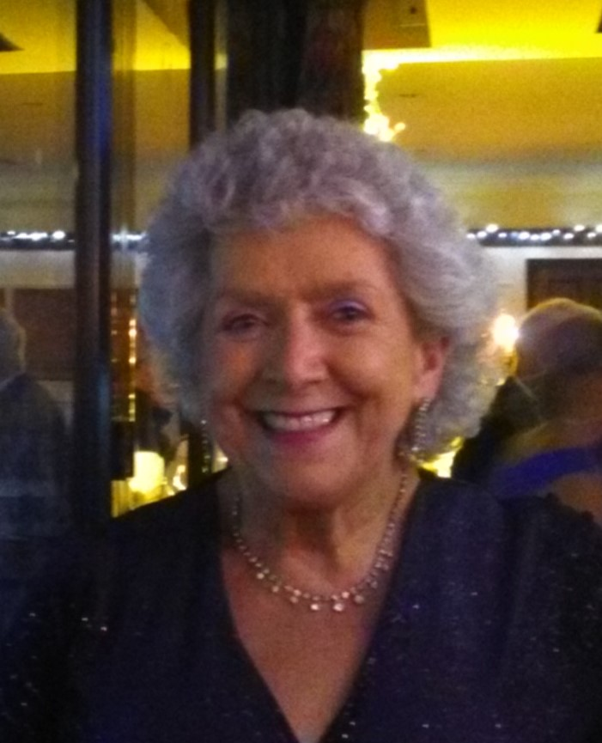
Once again, I wish to put my name forward to sit on the GMCDP Board to be able with disabled colleagues and staff to support the future of the Coalition.
Let us not be under any illusion these are tough times for our thirty five year old organisation. Despite the combined hard work of the original seven founders and the ongoing commitment of all involved with GMCDP over the years, many barriers for disabled people still remain.
For all my time on the board I was expertly managed and supported by Caron Blake who after 14 years as manager has recently stepped down from the role,
I welcome the appointment of Nicola McDonagh as the new manager.
And recognise that this marks a new era for the future of GMCDP and I look forward to working closely within the new management structure.
My specific area of interest is ensuring that disabled people can access mainstream opportunities and that barriers to their involvement are removed. I will continue to promote the importance of ensuring that individual access requirements are met.
GMCDP has always been relied on to adhere to this, and in doing so continues to be true to our mission statement.

Audrey Stanton
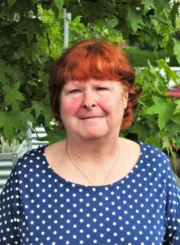
For the past 27 years I have been an active campaigner for the Disabled People’s Movement. In that time, I have been involved in many campaigns for the rights of disabled people.

I first became a member of GMCDP in September 1990 and have been a full member ever since. I feel that GMCDP is a massive part of my life and feel passionate about the aims of the organisation.

I was employed by GMCDP for nearly 20 years. In that time, I worked on the Young Disabled People’s Forum, helping shape it into a very successful project (which has been used as a model for other developing young disabled people’s forums). Whilst on the project, I helped develop the Forum’s drama group, who performed around the country and beyond (even as far as Bulgaria). I was also involved as a coordinator of the Young Disabled People’s Forum Independent Living Skills Training Project.

I feel that the Young Disabled People’s projects are a fantastic part of the Coalition. I am passionate about its continuation and am still involved with its development and I am involved in the Young Disabled People’s Sub Group. I am also keen to offer my support and advice to any young disabled people’s project as I feel I have a lot of experience. I also regularly volunteer in other areas of GMCDP whenever I can.

Deborah Bhatti
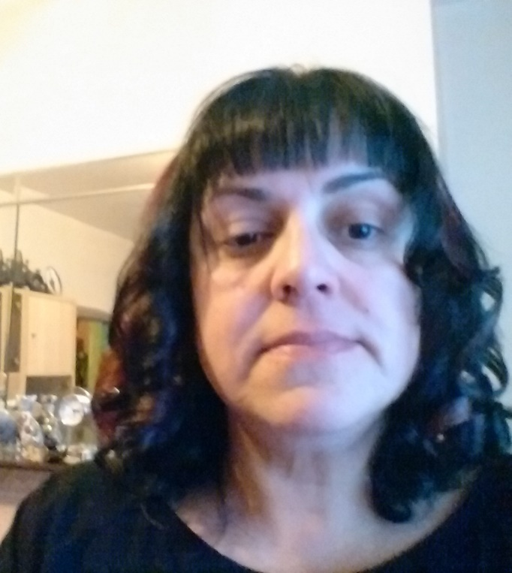
I want to nominate myself as I am a disabled person with physical disabilities, as well as autism and mental health difficulties and I feel people with my disabilities are not well represented. I am concerned about the level of hate crime towards disabled people and also emanating from public bodies such as NHS, councils, housing, education.
I am concerned about lack of access to advocacy and welfare rights as well as access to legal aid.
As well as being disabled I am a care lever and this was a very damaging and abusive system. I have been homeless for many years and don't have any support. I have been a trustee at Bury involvement group for a few years and try to help other members access advocacy and support. I am also interested in in BAME issues. I have experienced racism a lot and this has impacted a lot upon my disabilities and mental health.
I want to join the Executive committee to be influential in highlighting and shaping services for other disabled people to be better and to look at marginalization and greater support for people outside of the City of Manchester which at present is under represented.

Dennis Queen
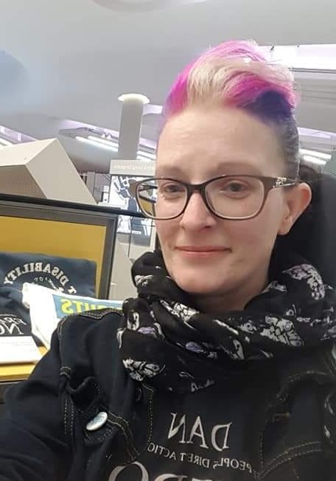
Dear GMCDP members,
I am Dennis Queen. I used to be Clair Lewis. I am 46, genderqueer, a parent of three disabled children, and I have various impairments.
Thank you for voting me into the exec last year! Thank you to Martin Pagel for nominating me again, I am extremely proud of that.
I have just finished my first year on the executive committee.
It is a big change for me and I am still learning the job. I am especially interested in growing our membership and supporting campaigns.
GMCDP members have worked hard this year campaigning, especially around access to the Peterloo Memorial. I attended my first council meeting, which was strange because everyone sits very still and talks flat.
My children are growing up and I am really enjoying being more involved in campaigning, organising and disability arts.
I would love to continue to represent you for the coming year.
The photo shows me with Lorraine Gradwell’s t-shirt at the library.

Heather Davidson
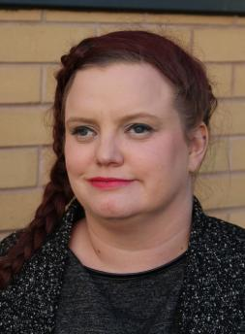
I am a passionate campaigner, policy researcher and influencer for disabled people and those who are members of the LGBTQ community.
With over 12 years experience of working as a youth worker and working on advisory boards, I have brought disability issues at the forefront of every role I've been in, most notably at the People History's Museum where I have helped set up the "The Year of Disability" in 2021. Prior to this I have ensured that disability history has been visible and honoured at exhibitions at the PHM.
As the chair of the GMCDP I have encouraged the membership to be more active, helped set up networking events so that there are regular opportunities for people to join in, connect and feel included. I have encouraged the GMCDP to broaden its skills set, valuing the contribution of each of its members. J want the GMCDP to be more visible and at the forefront of major campaigns in GM - namely transport issues, accessibility and feel that I am best place to do this with my broad skills and experience.
I am asking you to re-elect me so I can continue my hard work for members and disability issues.

Inga Reichelt
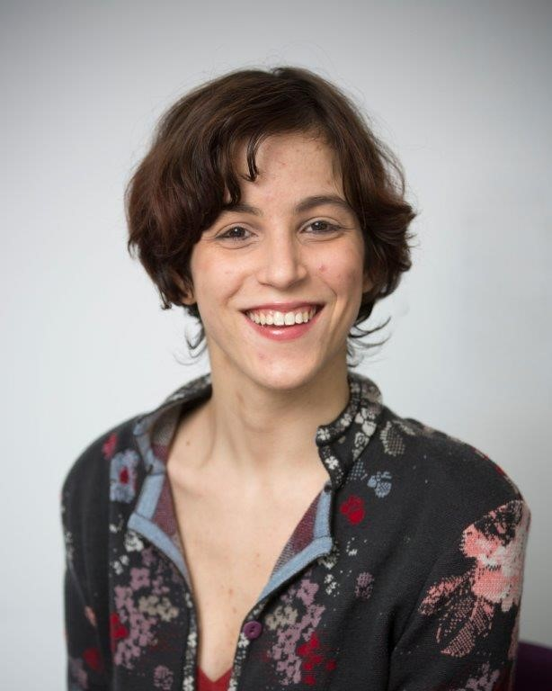
Hello!
My name is Inga and I was a GMCDP staff member from August 2018 to September 2019. I had to leave the job with great sadness due to health reasons, but I would love to stay actively involved with GMCDP.
Having been a staff member gives me a good insight into GMCDPs membership - having worked with many members regularly, its values and history, its organisational challenges, and its potential and outlook. As an Exec member, I would like to support the development of the podcast as a digital audio addition to the Coalition magazine, with provision of full written transcripts, to enable active member involvement and regularly inform the membership.
I am also interested in getting young people more involved, increasing the focus on how disabled people’s oppression is interlinked with other forms of oppression, and using social media and new communication technologies as an additional way of campaigning, alongside the more traditional protests, such as the Peterloo Memorial vigils. It would be an honour to be involved in an organisation with such a strong history and excellent track record of defending disabled people’s rights and furthering our participation.

Joe Whittaker
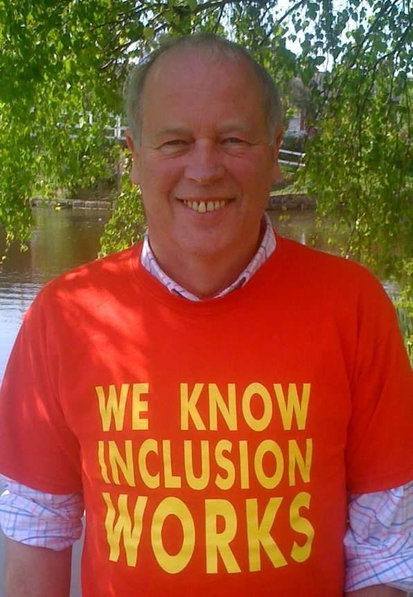
I would like to be accepted to continue on the GMCDP Executive for the coming year 2020, after which I intend to end my participation as executive member.

I have been actively involved in organised movements with disabled people for many years. I will continue to be active but without the important discipline of an organisation.

I do believe the autonomy of disabled people has been seriously damaged by this government over the past 9 years and I think as individuals and organisation have to work harder to fight back against the oppression of disabled people. We have to win back the freedoms that we worked hard to achieve and now enshrined within on the UN Convention on the rights of disabled people.

I am particularly committed to a fully supported inclusive education system, where difference is recognised as a strength and where we can come to value our own differences by upholding the differences in other.

Kevin Greenan
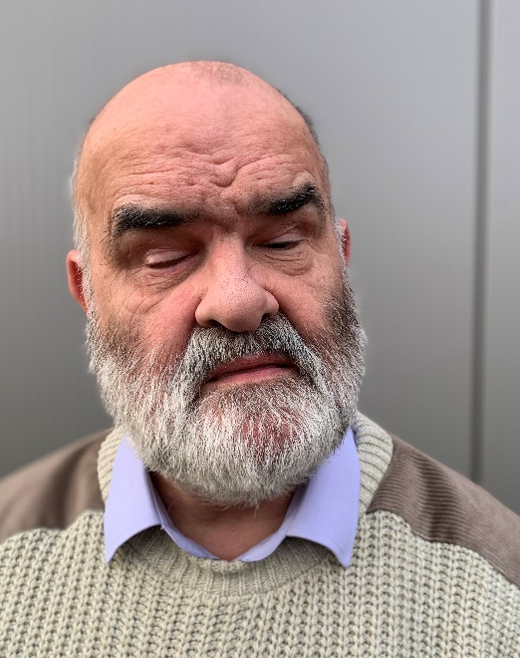
My name is Kevin Greenan! I am in my 65th year, and I am Blind. I arrived in Manchester from Ireland in July 1981, and eventually settled in Middleton the following year. After spending some time acquainting myself with my surroundings, I realised that I had moved into what was a thriving and developing community. The following year, I joined Middleton Dial, Disabled Information & advice line, where I was responsible for dealing with information concerning visual impairment. Shortly after that, I joined my local Tenants Association, in which I played an active role in assisting older & disabled tenants in having their houses adapted, ensuring that they were able to stay in their own homes. In 1984, I joined a local community centre, where I helped in promoting activities for people of all ages and disabilities, thus helping to break through the barriers of exclusion, and helping to remove the feeling of isolation, and get people to become more active in their community.
In the mid 90s, I joined RNIB, and became heavily involved in their campaigning process, especially in the promoting of the Higher Rate of the Mobility allowance. In 2007, I was invited to join AVIOS (the Association of Visually Impaired Office Staff), which later became The Association of Visually Impaired People, and represented them on the former RNIB UK assembly. I am also a member of NFBUK (National Federation of the Blind of the UK), where I campaign for safer streets and better access for the blind & Visually impaired. My home is owned by Rochdale Borough Wide Housing, which is a cooperative, and I serve on some of their Continuous Improvement Groups.
Two of the most important things for me are, access & inclusivity! I believe that all of us regardless of disability have a part to play in society, and should be able to access all areas and formats. It is vital that we all work together to ensure a better and fulfilling, & where possible independent life for all disabled persons right across the Greater Manchester area & beyond.

Maggie Griffiths
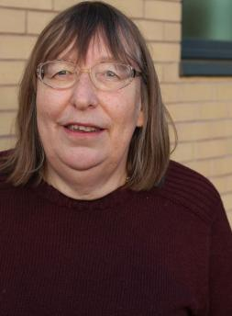
I first became involved in the Disabled People’s Movement and GMCDP as a non-disabled ally more than 30 years ago. I became a full member in 2014.
Since becoming a member of the Executive Council I have been extensively involved in the development of the policy and procedures needed to sustain an effective organisation and that are increasingly required by potential funders.
I have been involved in campaigning for many years and am an active member of GMCDPs campaigning subgroup.

Mathias Warrington
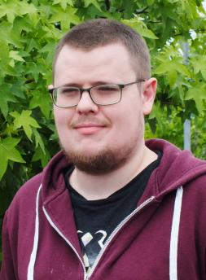
I have been involved in the GMCDP for the last 8 years and have been on the Executive Council since 2014.

For the last couple of years I have been the treasurer, and health and safety officer for the Coalition and would like the opportunity to continue in these roles.

I have been closely associated with the "Including Young Disabled People", "Consult With Disabled People" and "Shaping Our Inclusion" projects. Throughout this I have been involved with the strategic aspects of the projects, working on both the sub groups and the steering groups.

I'm currently involved in the Campaigning subgroup, the Finance subgroup and until recently the Young Disabled People subgroup.

I feel it is incredibly important that GMCDP continue to be at the very forefront of the disabled people’s movement.

In my spare time I enjoy reading, gaming (both board and video) and researching history.

Peter Marshall
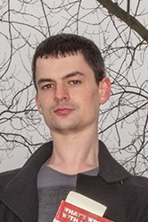
I have been working with various groups around autism and neurodiversity, I also have experience within the national and local autism scenes as both a grassroots leader. Around that, to be able to advocate as effectively as possible, I have been working with mental health and “Social Model” groups. This is because the autistic community is “new” and requires help networking with and establishing contacts and how/where to speak with the most effective voice.
I am also a member of several autistic groups and Manchester’s Autism Pride and have previously managed several social groups established by myself.
The Autism Partnership Board is a local council group which discusses projects around Manchester, liaising with professionals and autistic people (this is part of the Autism Act).
This is a very short snapshot but I’m always up to talk and I hope you feel you can vote for me.

Dr Paul Doyle
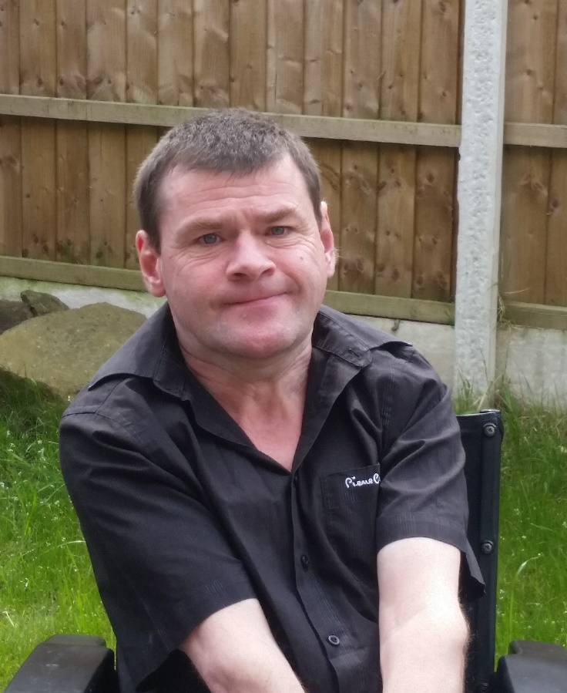
I have a PhD. The title of my thesis is, A study to raise the voices of young disabled people preparing for life beyond segregated school: the power of disability research in promoting advocacy. The fieldwork for this piece of research took place in a special school. One of the main outcomes of the work was that people with the most severe impairments were able to take part in the research.
I can encourage people with multiple disabilities, in particularly those with speech impairments, to speak up and say how they could have more independence in their lives. It needs to be recognised that people with multiple disabilities are full members of society.

Stephen Kingsberry
I have been a member of GMCDP for some time and was elected onto the executive council in 2012. I have been involved in other disability-related groups including Manchester council’s Visually Impaired Steering Group and the Physical Disabilities Partnership Board, and also the Learning Disability Partnership Board because I have an interest in this.

I produce audio programmes for the National Talking Express, which is an online audio magazine for the blind. There are two magazines, Media Roundup and National Talking Express. Though I say it myself, my programmes are excellent and should be enjoyed. I have also assisted at interviews for placing people in post for Manchester City Council. I have helped GMCDP find audio equipment and would like to continue supporting our organisation through involvement on the executive council.

Steve Graby
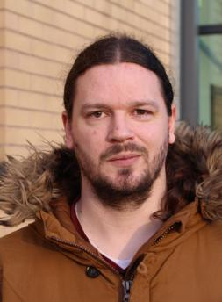
I have been on GMCDP's Executive board since 2013 and have been Deputy Chair since the last AGM in December 2018. In this time I have also done a PhD in Disability Studies at the University of Leeds. I am also a member of Disabled People Against Cuts (DPAC) and have been involved in the development by ROFA (Reclaiming Our Futures Alliance) of proposals for a National Independent Living Support Service. I believe that theory and action must both support each other, and that concepts that may seem abstract, such as the social model of disability and the principles of independent living, can and must be made accessible to all regardless of impairment or level of education.
In the upcoming year, I would like to strengthen GMCDP's inclusion of disabled people of all age and impairment groups and intersectional groups (such as people of colour, migrant communities and LGBTQ+ communities) and its connections with other movements and organisations in Greater Manchester with co-operative and mutual aid approaches, with the aim to make a real, practical difference to disabled people's lives focusing on issues such as accessible housing, personal assistance and financial security that are essential for independent living.

