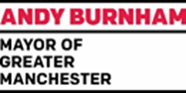
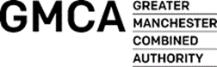
Greater Manchester
Mayor’ Disabled People’s Panel

The GM VCSE Accord sets out a new agreement between the Greater Manchester Mayor and Combined Authority and the Voluntary, Community and Social Enterprise sector based on a relationship of trust.
Our shared vision for the city-region is set out in the Greater Manchester Strategy Our People: Our Place - to make Greater Manchester one of the best places in the world to grow up, get on and grow old.

The Accord sets out a framework for the delivery of that shared vision and our commitment to reduce inequalities. We recognize this will only be achieved through new ways of working which are shaped and driven by our communities themselves.

Working with our partners in the GM Coalition of Disabled People, we will therefore champion new, improved standards of working with disabled people by establishing a Greater Manchester Disabled People’s Advisory Panel.

The Greater Manchester Mayor’s Disabled Peoples Panel will reflect the following key principles to:

- Support delivery of the Greater Manchester Strategy by strengthening the voice of disabled people in shaping and challenging policy
- Advise the Mayor and GMCA portfolio lead for Equalities, Fairness and Inclusion on key issues and help to develop solutions
- Consist of representatives of Disabled People’s Groups from across Greater Manchester
- Reflect the skills and knowledge of a diverse range of impairment specific groups
- Be transparent and accountable to its member groups and disabled people across Greater Manchester
- Reflect the 7 needs of Independent Living
- Be underpinned by the Social Model of Disability
- Be aligned to the principles of an inclusive society recognising that disabled people have full and equal rights
- Benefit all disabled people across Greater Manchester, irrespective of gender, race, ethnicity, faith, sexual identity or age.
The Greater Manchester Mayor and Combined Authority will work with the Greater Manchester Coalition of Disabled People supported by the Greater Manchester Centre for Voluntary Organisation to develop the panel as set out in the key principles including:

Strategic Development
- Establish membership of the Panel representative of GM Disabled People’s Groups
- Identify strategic priorities and developing a Work Programme based on the shared vision of the Greater Manchester Strategy

Organisational Development:
- Facilitate Panel meetings and developing a sustainable resource plan
- Liaise with key stakeholders including TfGM, the GM Health and Social Care Partnership and the GM Autism Consortium

Transparency and Accountability
- Develop a Code of Conduct, Terms of Reference and communication strategies

Evaluation
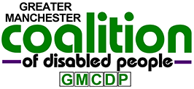
Produce an Annual Report of achievements and recommendations

