Greater Manchester Coalition of Disabled People
Executive Council Voting Form

The Executive Council decides what GMCDP will do.
Members of GMCDP can say who they want to be on the Executive Council (voting).

Before we have voted for everyone together (called a block vote).
Now you can vote for each person.

You can choose how you want to vote:

- You can fill in this form. It must be in the GMCDP office by Tuesday 21st January.

- Or you can fill in this form and bring it to the Annual General Meeting.

- You can contact the GMCDP office for help by phone 0161 636 7534 or email info@gmcdp.com

- Or If you want someone else to vote for you fill in the Proxy form.

Anne Tober  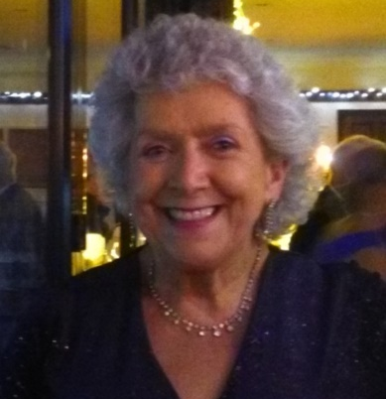 |  |  |  | Audrey Stanton  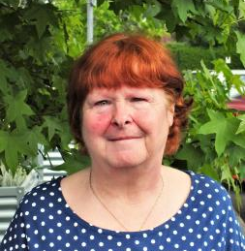 |  |  |  | Deborah Bhatti  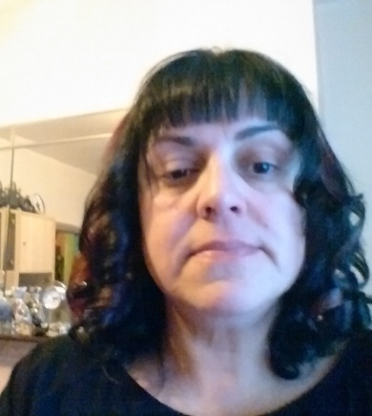
Dennis Queen  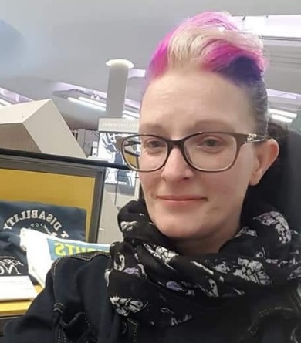 |  |  |  | Heather Davidson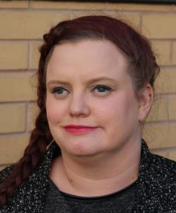 |  |  |  | Inga Reichelt  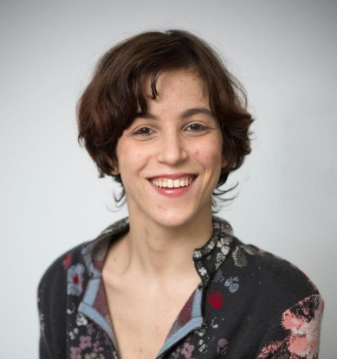
Joe Whittaker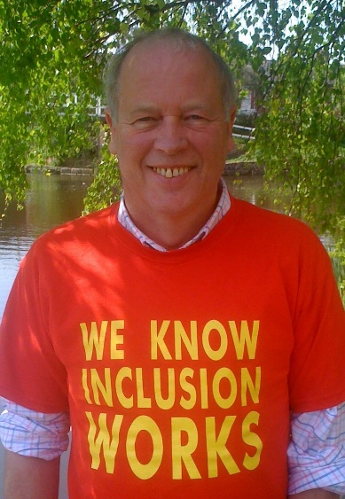 |  |  |  | Kevin Greenan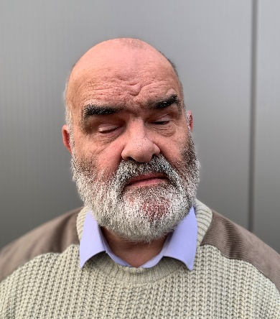 |  |  |  | Maggie Griffiths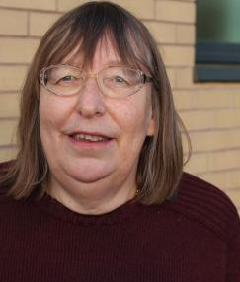
Mathias Warrington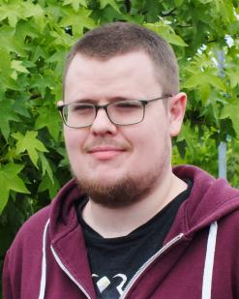 |  |  |  | Dr Paul Doyle  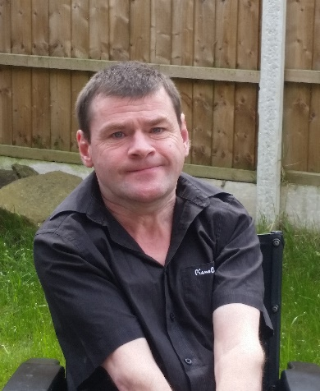 |  |  |  | Peter Marshall  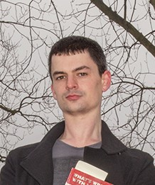
Steven Kingsberry |  |  |  | Steve Graby  