
Disability Pride: Lets Dance GMCDP – inclusive Dance workshop – easy read

When  Saturday March 28th 2026  Time  5pm till 9:30pm |     
Location  Lady Barn Community Hub  Royle street  Manchester  M14 6RN | 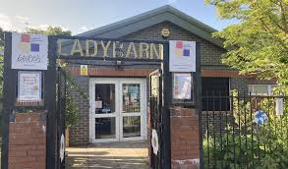
How to get there  Train  You can catch a train from Manchester Picadilly to Mauldeth Road train station where Lady Barn Community Hub is a short distance from.  Buses  You can catch the 142 , 42A, 43 and 143 and these buses will take you near to Ladybarn Community Hub. | 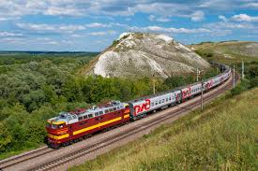  
Agenda  5:00PM – Arrival  5:30pm – Dance performance  6:00pm – Break with food provided  7pm – Dance performance | 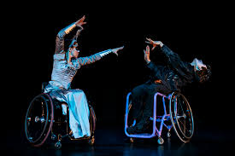  
Event information  Do come and join us for an incredible wheelchair dance performance which is performed by the stars from Propel Dance company at Lady barn Community Hub The dance company is an award-winning professional wheelchair dance company.  To read about what they do click on the link underneath.  https://propeldance.uk  Once the lunch break has finished there will be a dance workshop which will be inclusive. This workshop is based on wheelchair dance but open to anyone. Wheelchair users and people who can walk can join in or watch depending on what they prefer to do. | 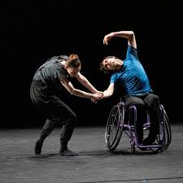  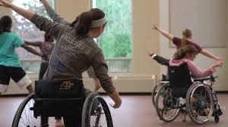
Children are welcome to attend but there must be a parent or guardian looking after them.  Dinner will be available. If you have dietary requirements, please share them as well as any other access needs you have. |   
How much  Tickets are free for anyone wishing to attend.  You can register for the event by click on the link underneath  https://gmcdp-inclusive-dance.eventbrite.co.uk  Even if the event is sold out, please do sign up as if a person cannot attend a ticket will be offered to you. | 
Please Note  We will take bookings until the events start if tickets are available still.  For bookings made after Thursday 26th March we may not be able to meet request such as dietary needs, PA bookings or taxis that you book.  You can still arrange your own travel and claim back your money later(Manchester residents only)  Your own PA/carer can come along with you  As we always do we are catering for vegetarian, gluten free and vegan. |         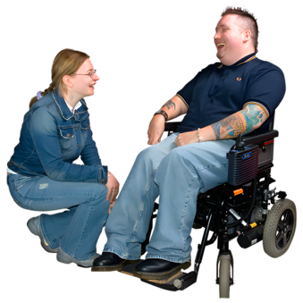
If you’re interested in attending the event but want to find out more information, then email Kayla@gmcdp.com or phone them or text on 07367755691 and they will be able to answer any questions about the event. | 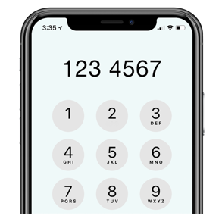
We do hope you can attend the event and we look forward to seeing you if you can. | 

