
Social and Open Mic Evening – Easy read

Do come and join an exciting night for an evening of food, socialising and talent showcasing in Manchester city centre.  We are returning at IABF to celebrate everyone and things GMCDP as we get ready to start a new three year grant.  The event will be run by Greater Manchester Coalition of Disabled People. | 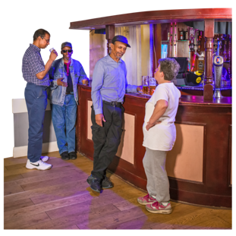
Location  International Anthony Burgess Foundation (IABF)  3 Cambridge Street  Manchester City centre  M1 5BY | 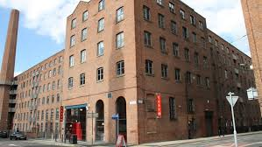
How to get there  There are many ways you can get to IABF by train bus or car. The nearest train station is Oxford Road and there are lots of bus routes nearby on Cambridge Street, Oxford Road and Chester Road.  There are no designated car parks but lots of pay and display car parks if you are planning driving and parking your car. | 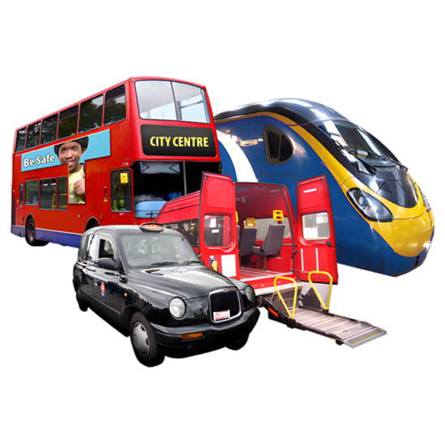
When  Tuesday March 31st | 
Time  5pm till 10pm | 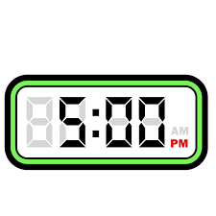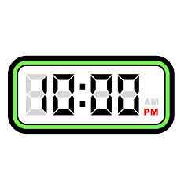
At the event there will be food and drinks for free and if you want to you are welcome to take part in the talent show part of the evening by performing a song, playing an instrument, reading a poem, telling jokes, doing circus skills, and much more ….. | 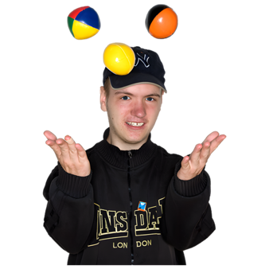
A room will be available for quiet time. | 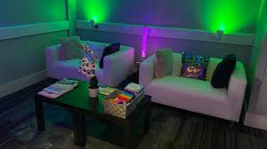

Notes:

Two BSL interpreters have been booked for the event. | 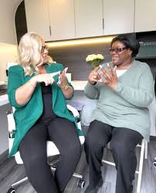
Before the event starts your welcome to book if tickets are still available | 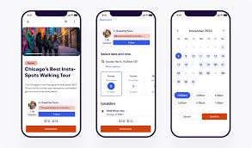
If you book after Friday 27th March, we may not be able to meet your requirements for dietary needs, PA booking and/or taxis that we book.  It’s important you request what you need so that we can contact you about what is possible. | 
If you want to arrange your own travel your welcome to and can claim back later (Manchester residents only) | 
The event is free to attend. | 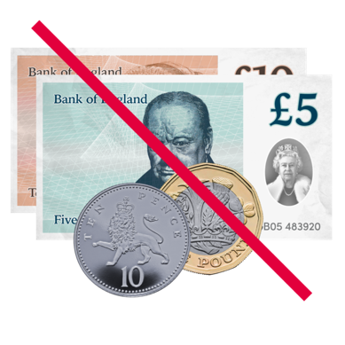
As standard we are already catering for vegetarian, vegan and gluten free. | 
Any questions about the event you can contact Kayla on 07367 755 691 or email them at Kayla@gmcdp.com. | 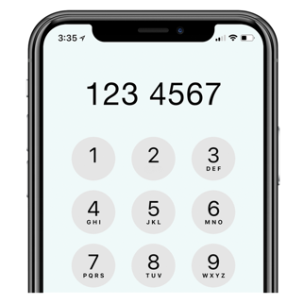
To book onto the event you can book onto it on the Eventbrite link underneath  https://www.eventbrite.co.uk/e/gmcdp-social-and-open-mic-evening-tickets-1983865377749?aff=oddtdtcreator  If you find it difficult to book on to the event online, you can email Kayla@gmcdp.com or contact them on 07367 755 691. |   
We hope you can come to the event and look forward to seeing you if you can attend. | 

