Application Pack

Archive Project Assistant

28 hours per week

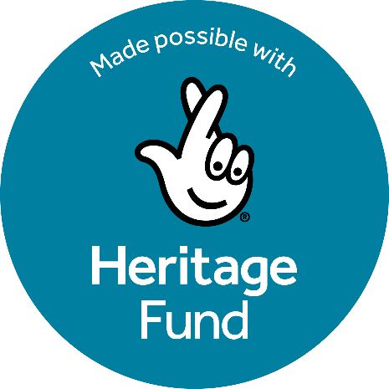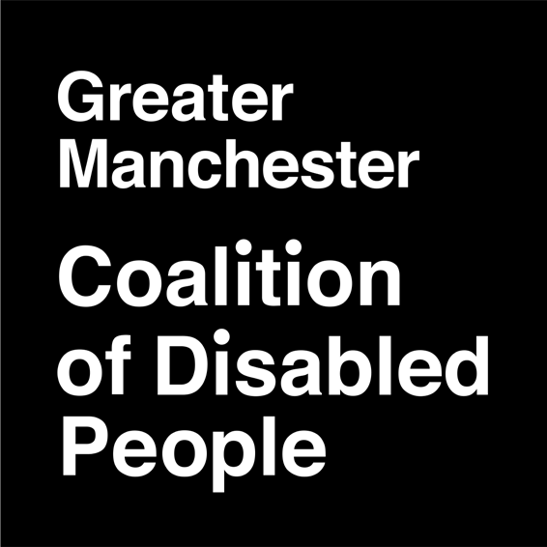

Contents 2

About Us 3

About the organisation 3

About the Disabled People’s Archive 4

About the project 5

Job Description 6

Terms 6

Who is this post open to? 6

Who do you mean by disabled people? 6

Purpose of the job 7

Main duties 7

Person Specification 9

Personal Values 9

1. Knowledge 9
2. Skills 10
3. Experience 10
4. General 11

How to apply 12

## About the organisation

Greater Manchester Coalition of Disabled People (GMCDP) is an organisation of disabled people, which works to promote the full inclusion of disabled people in society and challenge the discrimination and oppression of disabled people. It is completely run and controlled by disabled people. We specifically aim to:

* Promote the independence and inclusion of disabled people in society
* Encourage and support the self-organisation of disabled people
* Actively promote the understanding and implementation of the social model of disability
* Use the wealth of knowledge of disabled people to strengthen and develop our organisation and its projects
* Be a welcoming organisation that makes it easy for all disabled people to be involved.

## About the Disabled People’s Archive

The Disabled People’s Archive (DPA) is run in partnership with Archives+ and records the history of disability activism in Manchester, Britain and around the world. The project exists to give disabled people access to their own history, and to work with other archives, libraries, and other services to make heritage more accessible.

* The DPA is the largest collection in Europe of material created by disabled people and their organisations.
* DPA staff adapt historical documents and records to be accessible to people with sensory impairments and learning difficulties.
* Our team supports academic and community researchers to understand the history of disability and disability politics in Britain and internationally.
* The archive team provides training and written guidance to heritage staff on disability equality and accessibility and advises partner organisations on best practice for access and inclusion.
* DPA workers promote disabled people’s history and the social model of disability by showing how disabled people have changed society and fought against segregation and oppression through our collection.
* The DPA is overseen by a Steering Group of disabled activists and represents the interests of the Disabled People’s Movement in everything it does.

This is an exciting opportunity for a candidate to be able to both build on the previous good work of this project, as well as shape new approaches and activities.

## About the Accessing Our History Project



The Disabled People’s Archive’s new exciting project ‘Accessing Our History’ is funded by The Heritage Lottery Fund. Using money raised by National Lottery players, The National Lottery Heritage Fund supports projects that connect people and communities with the UK’s heritage. Thanks to National Lottery players, we have been able to ensure this important collection is now showcased with accessible workshops and events, ensuring our history does not remain hidden, and that disabled people have access, inclusion and are represented in the heritage sector.

* The Accessing Our History Project is set to launch in Autumn 2025, which is a significant year as it is GMCDP’s 40th anniversary. This project will celebrate the work of individuals, groups and organisations across the Disabled People’s Movement.
* The project is an opportunity to promote and celebrate the catalogued collection of the Disabled People’s Archive with new audiences across Greater Manchester.
* We will do this through a series of events, education workshops, archive sessions and a community archive outreach programme, blending accessible in-person, hybrid and online opportunities throughout.
* Some of these sessions will have a focus on the wider heritage sector, focusing on accessibility and representation.

# Job Description

### Terms

**Job title:** Archive Project Assistant

**Hours:** 28 hours per week

**Salary:**Starting at £18,746 (which is £23,433 pro rata). With provision for a promotion after 12 months, then rising to £22,056 (£27,570 pro rata).

**Location:** Hybrid (Primary Location: Manchester Central Library) alongside remote working & community outreach visits

**Working hours:** Monday – Thursday (alongside Archive Team)

**Reports to:** GMCDP CEO (supported by Archive Lead on day-to- day basis)

**Contract length:** 20 months

**Contract type:** Part-time until project end date of April 30th 2027

**Deadline for applications:** Sunday 19th October 2025

**Provisional interview dates:** Week ofMonday 27th -Thursday 30th October 2025; TBC

### Who is this post open to?

GMCDP is a disabled people’s organisation which is 100% run and controlled by disabled people. This post is therefore open to disabled people only.

### Who do you mean by disabled people?

We mean anyone facing disabling societal barriers in relation to their impairments or conditions. This includes physical impairments, mental distress or illness, hearing or visual impairments, learning impairments, D/deaf people, neurodivergent people, and those with chronic illness / long term health conditions.

### Purpose of the job

As the Archive Project Assistant, you will be responsible for supporting the Archive Lead and Archive Project Worker to promote, showcase and make accessible the Disabled People’s Archive. You will support the smooth running of the project through undertaking administrative tasks, including: organising workshops, sessions, meetings and events; booking venues; arranging for access provision, such as BSL interpreters, personal assistants and taxis; adding updates to our website and social media; supporting our transcription work; supporting the maintenance of our archive and records; maintaining day-to-day communications, and responding to enquiries.

Full training will be provided for this role, including accessible standards for information provision, organising accessible events, and understanding archive systems and protocols.

There is scope for this role to develop into that of Archive Project Worker after the first twelve months.

### Main duties

* Support the organisation and delivery of workshops, sessions and events, including room hire, liaising with external partners, booking BSL interpreters and PAs, and providing administrative event/session support on the day, both for in person and remote/hybrid activities
* Support the team in developing, planning, and delivering a series of workshops, training sessions, and drop-in advice sessions for heritage sector partners. These sessions will focus on accessible cataloguing and archiving, as well as on making both activities and roles within the heritage sector more accessible and inclusive
* Utilize established GMCDP links with other disabled people’s organisations, community groups and other agencies to promote our project and the Disabled People’s Archive.
* Work with the project team to produce and distribute a range of accessible resources, using traditional and creative methods (such as bulletins, magazines, videos, podcasts, and social media) to support project delivery, reach, and impact
* Organise and support outreach activities where appropriate, attending and running meetings and events (some of which may be during the evenings and weekends).
* Support and maintain the ongoing monitoring and evaluation of project activities and systems, and contribute to regular progress reports.
* Maintain record-keeping systems and procedures for archival research.
* Support oral history interviews following training and with guidance from an oral historian.
* Work with the Archive Lead in evaluating donations for preservation and retention - some may be fragile and need careful handling, repair or conservation.
* Support the ongoing digitisation of the catalogue when appropriate.
* Maintain record-keeping, monitoring and evaluation systems.
* Support the project in transcribing material into accessible formats, including braille, easier-to-read, audio, large print, and text only documents. Liaise with other agencies for additional accessibility options and out-sourced transcriptions, such as British Sign Language (BSL) and easy-read.
* Support in updating and maintaining our website and building our social media presence. Respond to email, telephone and face-to-face enquiries about the project.
* Organise staff team meetings and DPA Steering Group meetings. Assist with the production of agendas, minutes, reports and presentations as necessary.
* Undertake such other duties that may from time to time be required for the smooth running of the project.
* Uphold GDPR, National and International Copyright Law, and principles of equality and inclusion in all the DPA’s activities.

# Person Specification

Applicants are advised that the shortlisting for this post will be based upon a demonstrated ability to meet the items identified here on the person specification.

#### Please ensure that you clearly explain how you meet these requirements when making your application by using the numbering system below. Create a document with each number and answer how you meet these requirements.

#### CV’s will not be considered.

### Personal Values

Must display a genuine commitment to equality of opportunity, an understanding of the barriers to full participation in society experienced by disabled people, and of how these can be removed.

### Knowledge

* 1. Knowledge of the social model of disability and the main barriers facing disabled people.
  2. A good general knowledge of administrative procedures and processes.
  3. Understanding of wider equality issues and the importance of Equal Opportunities.
  4. Understanding of the importance and limitations of confidentiality.
  5. Knowledge of/willingness to learn about the Disabled People’s Movement in Britain, and an understanding of its contribution to British society. **(Desirable)**

### Skills

* 1. Proven ability to communicate and network with both groups and individuals in a variety of settings. **(Desirable)**
  2. Ability to produce and present a variety of information in accessible and creative ways.
  3. Good computer skills, including in Word, Outlook, Excel and databases.
  4. Ability to support the development, planning and delivery of training, workshops and information sessions.
  5. Ability to create content and share stories, updates, events on our website and social media platforms such as Facebook, Instagram etc. **(Desirable)**
  6. Able to work on your own initiative and as part of a team.
  7. Good organisation and record-keeping skills.

### Experience

* 1. Experience of supporting or organising and running/facilitating accessible meetings, events, workshops or other group activities.
  2. Experience of maintaining, managing and using data systems to gather information for use
  3. Experience of networking, outreach and partnership building.
  4. Experience of producing information resources in an accessible way, using a range of methods to make it available to as wide an audience as possible.
  5. Experience of working, volunteering, or researching in an archival setting (**Desirable**)

### General

* 1. Applicant must be a disabled person (self-definition).
  2. Willingness to work flexibly, including very occasional evenings and weekend work.
  3. Willingness to develop skills and undertake relevant training.
  4. Willingness to learn about the disabled people’s movement and why it is important that this is accessible to disabled people.
  5. Willingness to undergo a Disclosure and Barring Service check.

# How to apply

Complete an application form by making a document to clearly explain how you meet the requirements in the person specification. Do this by numbering your answers to match the numbers of each section. (Example, 1.1 – then your answer etc.)

Complete an equal opportunity monitoring form. This is optional and you do not have to answer all the questions if you don’t feel comfortable to.

Email your completed forms with the job title in the subject line to [info@gmcdp.com](mailto:info@gmcdp.com) by **12 noon on Sunday 19th October 2025.**

Please do not send a C.V. it will not be considered.

If you'd like an informal conversation about the role before applying, email [ella@gmcdp.com](mailto:ella@gmcdp.com).