Application Pack

Archive Catalogue Project Worker

21 hours per week

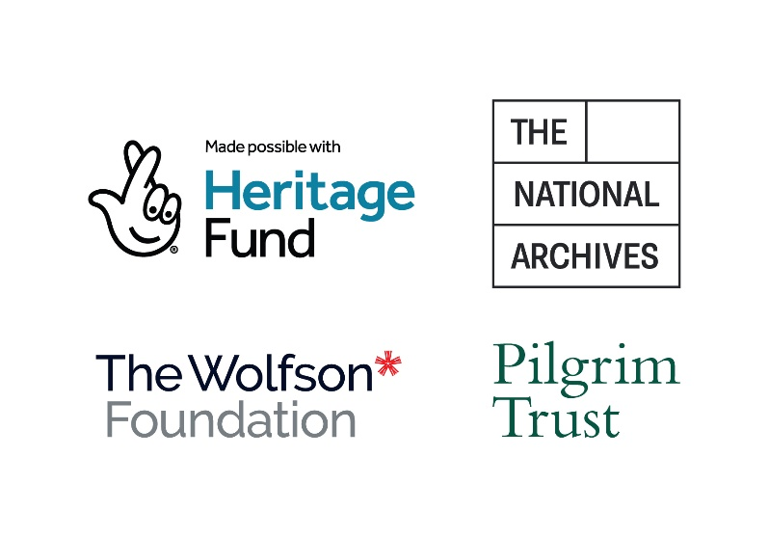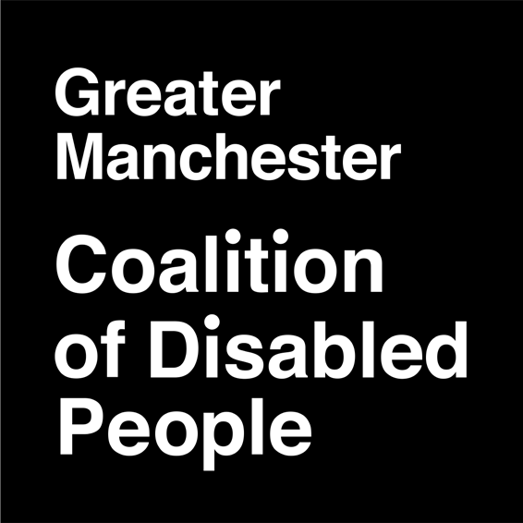

Contents 2

About Us 3

About the organisation 3

About the Disabled People’s Archive 4

About the project 5

Job Description 6

Terms 6

Who is this post open to? 6

Who do you mean by disabled people? 6

Purpose of the job 7

Main duties 8

Person Specification 10

Personal Values 10

1. Knowledge 10
2. Skills 10
3. Experience 11
4. General 11

How to apply 13

## About the organisation

Greater Manchester Coalition of Disabled People (GMCDP) is an organisation of disabled people, which works to promote the full inclusion of disabled people in society and challenge the discrimination and oppression of disabled people. It is completely run and controlled by disabled people. We specifically aim to:

* Promote the independence and inclusion of disabled people in society
* Encourage and support the self-organisation of disabled people
* Actively promote the understanding and implementation of the social model of disability
* Use the wealth of knowledge of disabled people to strengthen and develop our organisation and its projects
* Be a welcoming organisation that makes it easy for all disabled people to be involved.

## About the Disabled People’s Archive

The Disabled People’s Archive (DPA) is run in partnership with Archives+ and records the history of disability activism in Manchester, Britain and around the world. The project exists to give disabled people access to their own history, and to work with other archives, libraries, and other services to make heritage more accessible.

* The DPA is the largest collection in Europe of material created by disabled people and their organisations.
* DPA staff adapt historical documents and records to be accessible to people with sensory impairments and learning difficulties.
* Our team supports academic and community researchers to understand the history of disability and disability politics in Britain and internationally.
* The archive team provides training and written guidance to heritage staff on disability equality and accessibility and advises partner organisations on best practice for access and inclusion.
* DPA workers promote disabled people’s history and the social model of disability by showing how disabled people have changed society and fought against segregation and oppression through our collection.
* The DPA is overseen by a Steering Group of disabled activists and represents the interests of the Disabled People’s Movement in everything it does.

This is an exciting opportunity for a candidate to be able to both build on the previous good work of this project, as well as shape new approaches and activities.

## About the Choice and Control Project

The “Choice and Control” Cataloguing Project is funded by The Archives Revealed Cataloguing Grant from The National Archives. Archives Revealed is the only grant programme in the United Kingdom (UK) dedicated to the cataloguing and unlocking of archival collections. The programme is funded by [The National Lottery Heritage Fund](https://www.heritagefund.org.uk/), [the Pilgrim Trust,](https://www.thepilgrimtrust.org.uk/)[the Wolfson Foundation](https://www.wolfson.org.uk/) and [The National Archives](https://www.nationalarchives.gov.uk/archives-sector/grants-and-funding/). The goal of Archives Revealed is to ensure that significant archive collections, representing the lives and perspective of all people across the UK, are made accessible to the public for research and enjoyment.

* Many of the items in our “Choice and Control” catalogue project were previously restricted and hold significant historical, cultural and societal significance.
* Our collections contain the works of disabled people and our organisations from the 1970s to the 1990s - works that had a significant political and societal impact regionally, nationally, and internationally.
* The project is a chance for the Choice and Control collections to be fully catalogued, repackaged, and digitized to ensure their longevity.
* This work will then be promoted and celebrated with new audiences through engagement activities such as events, educational workshops, archive sessions, and a community archive outreach programme—offering accessible in-person, hybrid, and online opportunities throughout the project.

# Job Description

### Terms

**Job title:** Archive Catalogue Project Worker

**Hours:** 21 hours a week

**Salary:** £16,380 (£27,300 pro rate FTE).

**Location:** Hybrid (Primary Location: Manchester Central Library) alongside remote working & community outreach visits where appropriate

**Working hours:** Flexible

**Reports to:** GMCDP CEO (supported by Archive Lead on day-to- day basis)

**Contract length**: 20 months

**Contract type:** Part-time until project end date of April 30th 2027

**Deadline for applications:** Sunday 19th October 2025

**Provisional interview dates:** Week of Monday 27th -Thursday 30th October 2025; TBC

### Who is this post open to?

GMCDP is a disabled people’s organisation which is 100% run and controlled by disabled people. This post is therefore open to disabled people only.

### Who do you mean by disabled people?

We mean anyone facing disabling societal barriers in relation to their impairments or conditions. This includes physical impairments, mental distress or illness, hearing or visual impairments, learning impairments, D/deaf people, neurodivergent people, and those with chronic illness / long term health conditions.

### Purpose of the job

As the Archive Catalogue Project Worker, you will work with the Archive Team to develop and promote our collection, support researchers to access our movement’s history, and promote disability equality and co-production in the libraries, archives, and heritage world.

The post holder will be responsible for cataloguing, repacking and digitising the Choice and Control collections, working with the Archive Lead and Archive Team to promote, showcase and make accessible these collections as part of the Disabled People’s Archive. Our “Choice and Control” project will engage with multiple audiences, including disabled people, disabled people’s organisations (DPOs), researchers, students, academia and the heritage sector.

Full training will be provided for this role in accessible standards of information provision and running accessible events, as well as archive systems and protocols where appropriate.

Please note at the beginning of the role, it will be necessary for the project worker’s hours to overlap significantly with those of the Archive Team (Monday-Thursday) to support the new starter’s development and make them familiar with the collection, accessible information practices, and archival work. These hours will be reviewed by the GMCDP CEO as the post progresses.

### Main duties

* Developing an accessible and consistent catalogue of our Choice and Control collections with support from the Archive Lead; sorting documents and other materials by date, creator, and theme from our box lists according to ISADG (G) standards.
* Packaging the documents in suitable archival folders and boxes, placing boxes in archival storage, and recording their location as required.
* Working with the Archive Lead to identify material in the collection which requires repair or repackaging and working with our partners at Archives+ to ensure these repairs are carried out swiftly and efficiently.
* Working alongside the Archive Lead to identify and assess sensitive and private material in our collection and treating this material appropriately.
* Highlighting events, themes and documents within the collections to create accessible engagement materials for use later in the project. This will include generating subtitles and audio descriptions for videos, Plain English translations of text, and screen-reader accessible documents.
* Supporting the Archive Team with outreach activities based on themes in the collections; attending and running meetings and events, some of which may occur during evenings and weekends.
* Supporting our team of volunteers, in liaison with the Archive Lead, to develop their skills and build a sense of ownership over the project.
* Working with colleagues and the DPA’s Steering Group to develop our practices and policies and reporting regularly on project activities alongside other DPA staff.
* Supporting the Archive Lead and Steering Group in monitoring and evaluating the project for funder reporting.
* Upholding GDPR, National and International Copyright Law, and the principles of equality and inclusion in all the DPA’s activities.

# Person Specification

Applicants are advised that the shortlisting for this post will be based upon a demonstrated ability to meet the items identified here on the person specification.

#### Please ensure that you clearly explain how you meet these requirements when making your application by using the numbering system below. Create a document with each number and answer how you meet these requirements.

#### CV’s will not be considered.

### Personal Values

Must display a genuine commitment to equality of opportunity, an understanding of the barriers to full participation in society experienced by disabled people, and of how these can be removed.

### Knowledge

* 1. Knowledge of the social model of disability and the main barriers facing disabled people.
  2. Understanding of wider equality issues and the importance of Equal Opportunities.
  3. Understanding of the importance and limitations of confidentiality.
  4. Knowledge of the Disabled People’s Movement in Britain, and an understanding of its contribution to British society. **(Desirable)**

### Skills

* 1. Proven ability to communicate and network with both groups and individuals in a variety of settings.
  2. Ability to produce and present a variety of information in accessible and creative ways.
  3. Good computer skills, including in Word, Outlook, Excel and databases. **(Desirable)**
  4. Attention to detail, ability to problem solve and good organisation skills.
  5. Able to work on your own initiative and as part of a team.
  6. Ability to work with and support disabled people to take part, lead, and volunteer in project activities. **(Desirable)**

### Experience

* 1. Experience of, or demonstrable interest in, working in the archives, information, or heritage sectors.
  2. Experience of managing large data sets and providing relevant information to the public on request.
  3. Experience of producing information resources in an accessible way, using a range of methods to make it available to as wide an audience as possible.
  4. Experience of cataloguing in an archive, library, museum or similar environment or experience of editing online content.
  5. Experience of reporting to committees or steering groups and carrying out collective decisions (preferably in an activist group or non- governmental organization) (**Desirable**).
  6. Experience of working, volunteering, or researching in an archival setting (**Desirable**)

### General

* 1. Applicant must be a disabled person (self-definition).
  2. Willingness to work flexibly, including very occasional evenings and weekend work.
  3. Willingness to develop skills and undertake relevant training.
  4. Willingness to learn about the disabled people’s movement and why it is important that this is accessible to disabled people.
  5. Willingness to undergo a Disclosure and Barring Service check.

# How to apply

Complete an application form by making a document to clearly explain how you meet the requirements in the person specification. Do this by numbering your answers to match the numbers of each section. (Example, 1.1 – then your answer etc.)

Complete an equal opportunity monitoring form. This is optional and you do not have to answer all the questions if you don’t feel comfortable to.

Email your completed forms with the job title in the subject line to [info@gmcdp.com](mailto:info@gmcdp.com) no later than noon on Sunday 19th October 2025

Please do not send a C.V. it will not be considered.

If you'd like an informal conversation about the role before applying, email [ella@gmcdp.com](mailto:ella@gmcdp.com).