
Afternoon tea at the Hilton Hotel
Come and enjoy afternoon tea at the Hilton Hotel whilst looking at the bird’s eye view of the skyline of Manchester. | 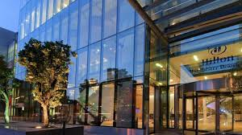
Please come and join us on Friday 24th January 2025 at the Cloud 23 at the Hilton Hotel. | 
Please arrive at 11:30am .  Afternoon tea runs from 12pm till 3pm approximately | 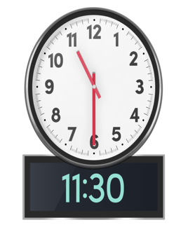  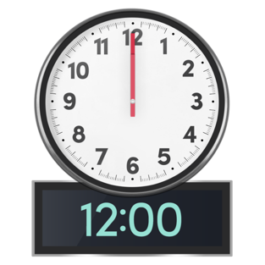
When you join us for Afternoon Tea at Cloud 23 at the Hilton you will be offered a variety of finger sandwiches, pastries, and scones. | 
The Hilton Hotel offers veggie, vegan, gluten free, nut free and a low salt afternoon tea options if required .  Note: the kitchen does have food that contains, gluten or nuts (just in case your allergy is severe) | 
Travel expenses can be covered but a copy of the receipt is needed. Ask for details if needed.  If you need a wheelchair taxi, we can arrange to pay for one if needed. When you register just say if you need this and we can book it.  Taxis can drop off and pick you up outside the building.  Please let us know if you want someone to meet you outside. |   
The Hilton Hotel is located at  303 Deansgate Manchester M3 4LQ  It is a 3 minute walk from Deansgate Castlefield tram stop and ten minutes from Oxford Road train station | 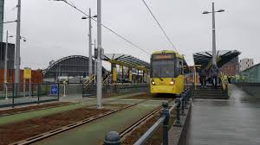  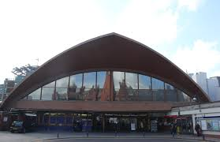
There is a car park which is located just 8 minutes away. The address for it is.  NCP Car Park  Manchester Central,  Lower Mosley Street,  Manchester  M2 3GX | 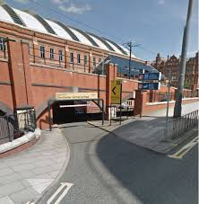
The afternoon tea is free at the venue.  If you need a PA let us know and we can book one for you.  Your PA , if you need one, can also have a free afternoon tea. | 
To book on the event you can book online.  The link underneath is for you to book online  https://gmcdp.com/civicrm/event/register?id=435&reset=1  If you prefer :-  you can email kayla@gmcdp.com or phone 07367 755 691.  Please sign up on the waiting list as people might cancel. You will be contacted if a ticket becomes available.  We look forward to seeing you at this GMCDP event if you can make it. |   

