Saturday 09 November
Location  HOME  2 Tony Wilson Place  Manchester  M15 4FN | 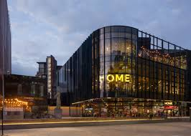
The theatre show is on the 9th is called Follow the Signs.  A little summary of the show  It’s about a person called Chris who is deaf but is living around people who can hear and are in the hearing world.  More information can be found on the link below  https://homemcr.org/production/follow-the-signs/ | 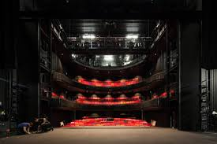
At 6pm when you arrive there will be cake and drinks. | 
The show lasts for an hour roughly from 7:45pm till 8:45pm. | 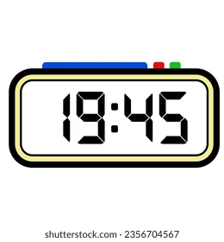
The Show has (BSL) British Sign Language and is captioned which means there is text on a screen for anyone who is hard of hearing. | 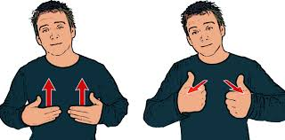
Content warning  - The show includes bullying, discrimination, and audism.  - Audism is not treating a person the same as others because they cannot hear. | 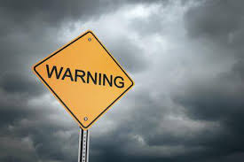
Lighting  If you have epilepsy then the lighting might be a trigger as there are flashing lights in the show. | 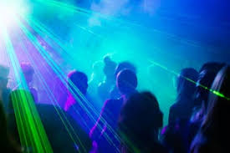
Greater Manchester Coalition of Disabled people (GMCDP) will pay for drinks and nibbles. | 

To book you can click on the link which is provided underneath.  https://gmcdp.com/civicrm/event/info%3Fid%3D410%26reset%3D1  You can send Kayla an email at Kayla@gmcdp.com .  If you prefer text or phone Kayla on 07367 755 691. | 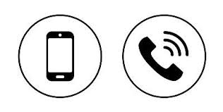

This Easy read guide was put together by Amber Okpa-Stother. | 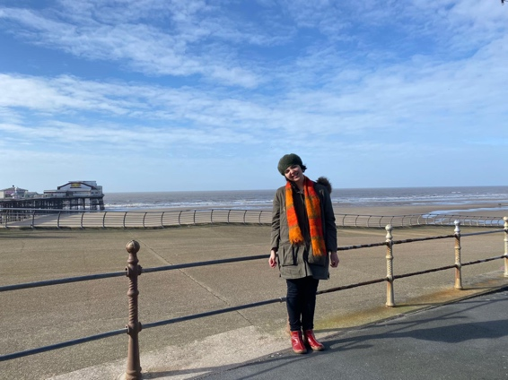
I hope that you enjoy the social events when you go, and we look forward to seeing you at one of them. | 

