GMCDP Events

- Kayla from Greater Manchester Coalition of Disabled People (GMCDP) organises social gatherings. | 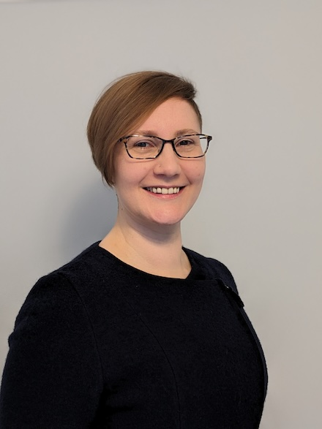
- The social gatherings are for people who have any sort disability and live in Manchester.  - Anyone is welcome to meet new people and come to the events. | 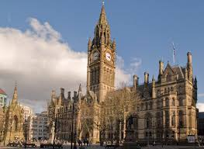
- If you can join us, we would love you to but don’t worry if you can’t. | 

What happens at each event?

How much?  The events are free for you to attend. | 
If you’re attending with a PA (personal assistant) this could be your parents, friend, or a carer they can have a free ticket too. | 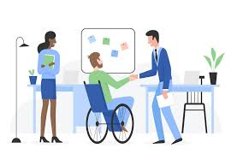
We can arrange and book a personal assistant in advance if you require one. | 
Taxis can be arranged if needed. A wheelchair taxi can be sorted if required too. Please let us know if you need a taxi. | 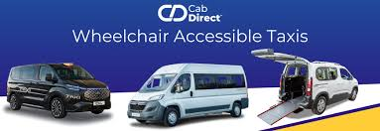
If you have paid for your tram or bus fare, we can give you money back for your ticket. You will need to show us your ticket.  People who have a disability are entitled to a free bus pass in Manchester the pass can also be used on trams and on trains at a certain point.  Click on the link to find out more.  https://www.manchester.gov.uk/info/500351/public_transport/2510/concessionary_travel_passes | 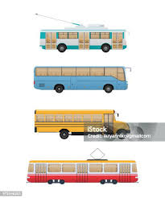

We can send you some documents before the event.  The documents will have photos and directions to help you find where you need to get to. | 
Someone can meet you outside the venue if it would be helpful.  Two examples of the venue might be the theatre or the cinema. | 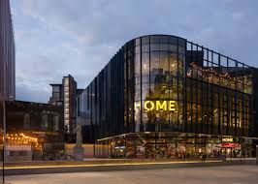

This Easy read guide was put together by Amber Okpa-Stother. | 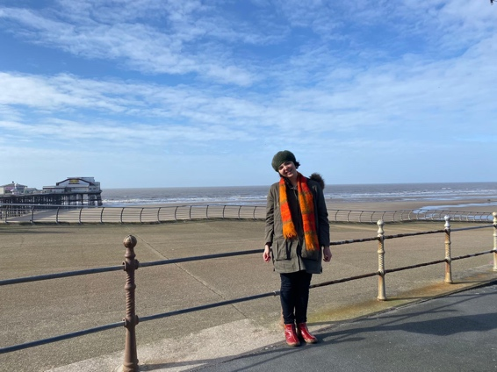
I hope that you enjoy the social events when you go, and we look forward to seeing you at one of them.

