Saturday 16th November

Location  HOME  2 Tony Wilson Place  Manchester  M15 4FN | 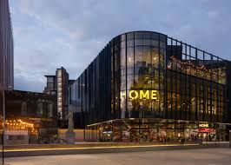
The musical show is called After the Act  After the Act is a 1980s musical show. To find out more information you can click on the link underneath.  https://homemcr.org/production/after-the-act/ | 
When you arrive at 12pm Greater Manchester Coalition of Disabled People (GMCDP) will provide your lunch. You will not have to pay for this.  Please us know if you have any dietary requirements on the contact details provided. | 
The running time of show is 60 minutes. The show runs from around 2-3pm. | 
To book you can click on the link which is provided underneath.  https://gmcdp.com/civicrm/event/info?reset=1&id=411  If you struggle booking online, you can email Kayla@gmcdp.com or call or text on 07367 755 691. | 

This Easy read guide was put together by Amber Okpa-Stother. | 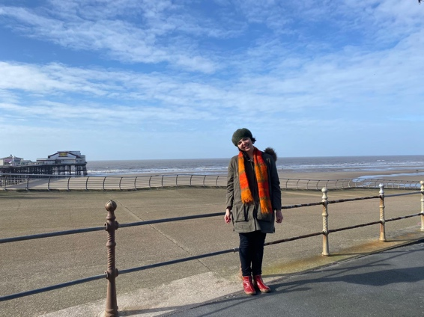
I hope that you enjoy the social events when you go, and we look forward to seeing you at one of them. | 

